Globe-Spanning Logistics (GSL)
Unit 5 Assignment

Composed by
Gordon Elliott Williams, MS, MBA, BS, AS

For
Dr. Mike Saxton
Post University
BIA565-30 Decision Support and Intelligent Systems 2025-26 Term 2

Table of Contents
- Prompt Used to Generate Fictitious Organization (in DeepSeek AI)
- AI-Generated Fictitious Organization Profile
- Core Services
- Key Technology Platforms
- MIS Architecture for a Global Logistics Leader
- Privacy and Governance Laws
- Information MIS Infrastructure
  - Backup and Recovery Planning
  - Disaster Recovery Planning (DRP)
  - Business Continuity Planning (BCP)
- Agile MIS Infrastructure
- Sustainable MIS Infrastructure
- Conclusion
- References

Prompt Used To Generate Fictitious Organization in DeepSeek

Create a fictitious international logistics organization. The company should be large, operating in multiple countries across North America, Europe, and Asia. Give it a name, a mission statement, a brief history, and describe its core services, which should include freight forwarding (air and sea), customs brokerage, and warehouse/distribution services. Mention its key technology platforms, like a global Transportation Management System (TMS) and a Warehouse Management System (WMS).

AI-Generated Fictitious Organization Profile

Name: Globe-Spanning Logistics (GSL)

Mission Statement: To deliver seamless, intelligent, and sustainable global supply chain solutions through innovative technology and a commitment to customer success, connecting businesses and communities worldwide.

History: Founded in 1995 in Atlanta, Georgia, as a regional freight forwarder, GSL expanded rapidly throughout the 2000s by acquiring smaller firms in Europe and Asia. Recognizing the dot-com boom's impact on global trade, GSL invested heavily in technology early on. By 2015, it had established itself as a major player in international logistics, known for its robust digital platforms and reliable service. Today, GSL operates in over 50 countries, with major hubs in Atlanta, Hamburg, and Shanghai.

Core Services
- Global Freight Forwarding: GSL manages complex international shipping for clients via air and sea, handling everything from booking cargo space to managing shipping documentation.
- Customs Brokerage: A dedicated team of in-house experts navigates the complex web of international trade regulations and tariffs to ensure swift, compliant customs clearance in every country of operation.
- Warehousing & Distribution: GSL operates a network of state-of-the-art warehouses offering storage, inventory management, order fulfillment, and last-mile delivery services.

Key Technology Platforms
GSL's operations are powered by two central systems: "Odyssey," a proprietary global Transportation Management System (TMS) that provides real-time tracking, freight optimization, and analytics, and "Apex," a sophisticated Warehouse Management System (WMS) that automates inventory control and fulfillment processes. These systems are integrated to provide clients with end-to-end supply chain visibility.

MIS Architecture for a Global Logistics Leader
The logistics industry forms the backbone of the global economy, and its reliance on sophisticated Management Information Systems (MIS) has never been greater. For a multinational logistics firm like Globe-Spanning Logistics (GSL), which operates across diverse regulatory landscapes and manages immense volumes of sensitive data, a robust and agile MIS architecture is not just a competitive advantage—it is a foundational necessity. This paper will assess the critical considerations for GSL's MIS architects, focusing on privacy and governance, information infrastructure for continuity, the principles of an agile infrastructure, and the adoption of sustainable technologies. These elements are crucial for ensuring GSL can navigate legal complexities, maintain operational resilience, adapt to market changes, and operate responsibly.

Privacy and Governance Laws
Operating in North America, Europe, and Asia exposes GSL to a complex patchwork of data privacy and governance laws, each with significant implications for its MIS architecture. The most prominent of these is the European Union's General Data Protection Regulation (GDPR). GDPR mandates strict rules for handling the personal data of EU citizens, including names, addresses, and contact information of shippers and recipients. For GSL, this means its systems, such as the "Odyssey" TMS, must be designed for "privacy by design," ensuring that data processing is secure, transparent, and limited to its intended purpose (Voloder, 2018). Architects must implement robust encryption for data in transit and at rest, establish clear data retention policies, and build mechanisms to handle data subject access requests (DSARs), allowing individuals to view, amend, or delete their personal information.
Similarly, in the United States, regulations like the California Consumer Privacy Act (CCPA) grant consumers similar rights over their personal information. Furthermore, GSL must contend with data sovereignty laws, such as those in China, which may require that data generated within the country's borders be stored on local servers. This directly impacts MIS architecture, forcing a move away from a single, centralized data center model. Instead, GSL must adopt a distributed data architecture, potentially using regional data centers or specific cloud regions to ensure compliance. This geo-fenced approach ensures that customer data from a specific region remains within that region's legal jurisdiction, preventing costly legal violations and building trust with international clients. The MIS design must therefore be modular and configurable to adhere to the strictest applicable regulation for any given data transaction.

Information MIS Infrastructure
For a logistics company, where the timely and accurate flow of information is as critical as the physical movement of goods, the information MIS infrastructure must be built for resilience. This is achieved through a cohesive strategy encompassing Backup and Recovery, Disaster Recovery (DR), and Business Continuity Planning (BCP).
Backup and Recovery Planning at GSL must go beyond simple data duplication. It requires a tiered approach where critical operational data—such as active shipment statuses in the Odyssey TMS, customs declaration forms, and real-time inventory levels from the Apex WMS—is backed up in near real-time. Less critical data, like historical financial records, can be backed up on a less frequent schedule. Architects must implement a solution that combines full, incremental, and differential backups stored in geographically separate locations (e.g., a primary backup in Atlanta and a secondary one in a Hamburg data center) to protect against localized disasters. Regular testing of data restoration procedures is non-negotiable to ensure backups are viable when needed.
Disaster Recovery Planning (DRP) focuses on restoring technological capabilities after a catastrophic event, such as a data center outage caused by a natural disaster or a major cyberattack. GSL's DRP should be built on a hot-site model for its critical systems. This means a fully operational, duplicate data center is running in standby mode at all times. If the primary Atlanta data center fails, the MIS can failover to the hot site in Hamburg or a cloud-based DR site with minimal downtime (Lattz, 2021). This plan must detail the exact failover and failback procedures, communication protocols for IT staff, and criteria for declaring a disaster.
Business Continuity Planning (BCP) is broader than DRP and addresses how GSL will maintain its core business operations during a disruption. While the DRP restores the technology, the BCP ensures employees can continue their work. For GSL, this could involve pre-established plans for rerouting shipments, using alternative warehouses, or having customs brokers work remotely by accessing cloud-based systems. The BCP identifies critical business processes, determines the maximum tolerable downtime for each, and outlines the manual or alternative procedures to be used if systems like Odyssey or Apex are temporarily unavailable. As noted by the SANS Institute (2019), a successful BCP integrates IT recovery with overall business process resilience, ensuring that even if a system is down, the parcels keep moving.

Agile MIS Infrastructure
An agile MIS infrastructure is one that can efficiently support the dynamic and unpredictable nature of the global logistics industry. It is characterized by seven key abilities that are paramount for GSL's success.
- Accessibility: GSL’s workforce, partners, and clients are globally distributed. The infrastructure must provide secure, web-based, and mobile access to systems like Odyssey and Apex from anywhere in the world.
- Availability: High availability is crucial. Downtime in a TMS can halt shipments, leading to massive financial losses and reputational damage. The infrastructure requires redundant servers, networks, and power supplies, aiming for "five nines" (99.999%) availability for critical applications.
- Maintainability: The system must be easy to update and repair. Using a microservices architecture, where applications are built as a collection of loosely coupled services, allows IT teams to update one component (e.g., the customs calculation module) without taking the entire system offline.
- Portability: Applications should be able to run on different platforms. By using containerization technologies like Docker and Kubernetes, GSL can ensure that its proprietary software can be moved between on-premises servers and different cloud providers without significant rework.
- Reliability: The infrastructure must be fault-tolerant. It should be able to detect and recover from hardware or software failures automatically. For instance, if a server running a component of the Apex WMS fails, a load balancer should automatically redirect traffic to a healthy server.
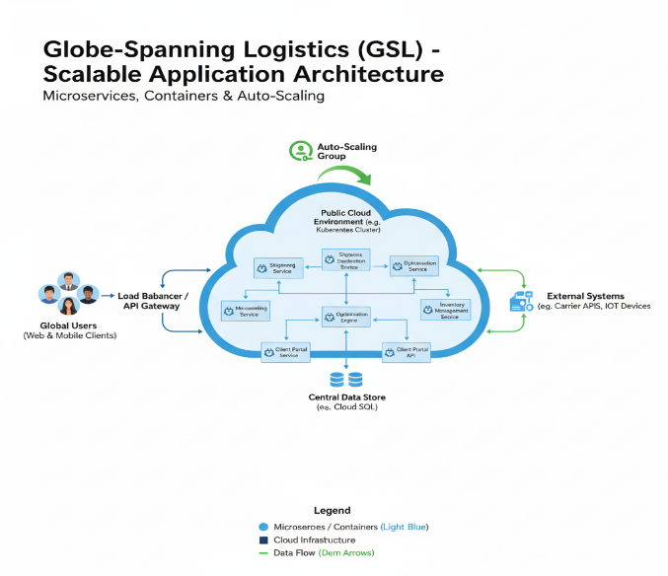
- Scalability: The logistics industry experiences significant fluctuations in demand, such as during holiday seasons or major sales events like Black Friday. The MIS infrastructure must be able to scale horizontally—adding more servers or computing resources on demand—to handle a surge in transactions and tracking requests, and then scale back down to control costs.
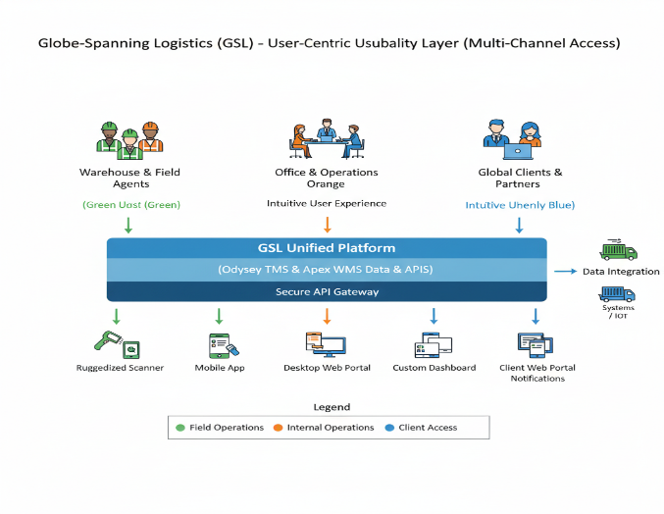
- Usability: The systems must be intuitive and easy for a diverse user base—from warehouse workers to financial analysts—to operate effectively. A well-designed user interface (UI) and user experience (UX) reduce training time and minimize operational errors.

Sustainable MIS Infrastructure
A sustainable MIS infrastructure, often called "green IT," aims to minimize the environmental impact of technology while enhancing operational efficiency. For a global company like GSL, Cloud Computing is the most effective strategy for achieving this.

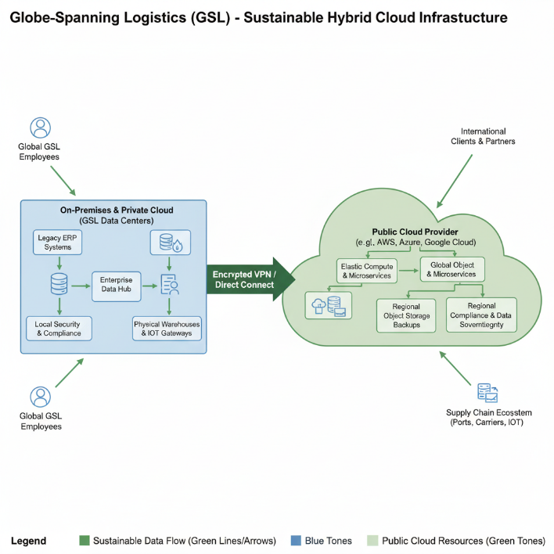
By migrating a significant portion of its infrastructure to a major cloud provider like Amazon Web Services (AWS), Microsoft Azure, or Google Cloud, GSL can dramatically reduce its carbon footprint. Large-scale cloud providers achieve massive economies of scale in their data centers, using advanced cooling systems, efficient hardware, and renewable energy sources far more effectively than a private company ever could (Lattz, 2021). Instead of maintaining power-hungry, underutilized servers in multiple office locations, GSL can leverage the provider's highly optimized infrastructure, paying only for the computing resources it actually consumes.
Virtualization, a core technology of cloud computing, allows multiple virtual servers to run on a single physical server, drastically increasing hardware utilization and reducing the number of physical machines needed. This directly translates to lower energy consumption and less electronic waste.
In conclusion, cloud computing inherently supports GSL's goals for an agile and resilient infrastructure. It provides the on-demand scalability needed to handle peak shipping seasons without over-provisioning hardware year-round. It also simplifies disaster recovery, as GSL can use the cloud provider’s global network to replicate data and applications across different geographic regions, creating a cost-effective and highly reliable DR solution. For example, GSL could run its primary Odyssey TMS instance in an AWS region in North America while continuously replicating data to another region in Europe. This sustainable approach not only aligns with corporate social responsibility goals but also offers tangible financial and operational benefits, making it an indispensable component of GSL's modern MIS architecture.

References
Lattz, J. (2021). IT infrastructure and emerging trends. University of Minnesota Libraries Publishing. https://open.lib.umn.edu/it/
SANS Institute. (2019). The essential components of a successful business continuity plan. SANS Institute Information Security Reading Room. https://www.sans.org/reading-room/whitepapers/recovery/essential-components-successful-business-continuity-plan-38965
Voloder, B. (2018). The GDPR: A game changer for data privacy and security. ISACA Journal, 2018(3), 1-5. https://www.isaca.org/resources/isaca-journal/issues

